Slope Stability Analysis Program DBS- IWHR2015

Introduction
The breaking of natural or synthetic dams often causes significant disasters, and the related research is in high demand. Estimation of the dam-break flood is of prime importance in such research,especially when dam safety emergency responses are concerned. In most of the existing dam breach analytical methods, the lateral enlargement of the channel is modeled using slope stability analysis methods. In these methods, the planar wedge failure mode is used in which the slip surface is assumed to be a straight line (Singh and Scarlatos, 1988; Osman and Thorne, 1988; Fread, 1988; Peviani, 1999; Mohamed et al., 2002; Zhu et al., 2006; D’Eliso, 2007; Huang, 2008; Morris et al., 2009b; Wang et al., 2008; Wu, 2013; Chang and Zhang, 2010; Viero et al., 2013; Peng et al., 2014; Dou et al., 2014). However, the geotechnical profession has widely accepted more rigorous analytical methods with circular slip surfaces, such as Bishop’s simplified method (1955) and the method proposed by the U.S. Army Corps of Engineers (1970). The procedure for calculating the factor of safety F is repeated among a variety of possible slip surfaces until a critical one associated with the minimum factor of safety Fm is found. This can be achieved by use of the grid methods, then followed by a procedure to find the critical depth of toe-cutting that makes Fm =1. The calculations can be performed by a computer program DBS-IWHR2015.

Instruction for use

Basic Function
The spreadsheet entitled DBS-IWHR 2015 is coded in Microsoft Excel 2013 with its VBA programming facilities. In DBS-IWHR, Bishop’s simplified method (1960) is used to calculate the factor of safety of a circular slip surface. DBS-IWHR 2015 has two basic functions: (1) Calculation for factor of safety. (2) Search for critical slip surface
Being based on program of Coulomb active earth pressure calculation on retaining wall and Lossap2009, DBS-IWHR2015 can cover the shortage of them:(1) Program of Coulomb active earth pressure calculation on retaining wall is a program for the Coulomb active earth pressure calculation in which the slip surface is a straight line;(2) LOSSAP2009 can not search for the critical surface.
DBS-IWHR provides an easy, transparent, and robust tool that could enable practicing engineers to perform dam breach analyses.

Layout
DBS-IWHR has 13 worksheets:
(1) Worksheet MAIN:
Fig. 1 (a) shows the main structure of Worksheet MAIN. It comprises three zones.
Zone A is located at the upper left corner. It contains all the inputs, such as the slope geometry, material property and the initial circular slip surface to be investigated. The details are contained in Chen et al. (2008).
Zone B is located at the lower, right part of the sheet. It contains the information of the details of slices, such as their weight, strength, and pore pressure ratio and so on.
Zone C is located at the upper right corner. It displays the calculated factor of safety and the graphic illustrations of the circle.

- Worksheets and flow charts
(2)Worksheet slip surface2-7:
DBS-IWHR adopts the grid search method to locate the critical slip surface. It consists of two rounds of searches. Worksheet slip surface2-7 show the process of first search which varies the x-coordinate of the circle center.

(3)Worksheet search:
In Worksheet search, a circle associated the minimum factor of safety F_{m} can be found. It is the minimum in the first search.
(4)Worksheet critical slip surface:
The detail information of the critical slip surface associated the minimum of the first search.
(5)Worksheet slip surface8-13:
Show the process of the second search which inherits the critical surface obtained in the first step by fixing the upper and lower points of interception and varying the radius of the arc.
(6)Worksheet search2:
In Worksheet search2, a circle associated with the refined minimum factor of safety can be found. It is the minimum in the second search.
(7) worksheet critical slip surface2:
The detail information of the critical slip surface associated the minimum of the second search.

Search for critical slip surface
DBS-IWHR adopts the grid search method to locate the critical slip surface. It consists of two rounds of searches.
The first search varies the x-coordinate of the circle center making a number of trial slip surface all passing the slope toe, as shown in Fig. 2(a). Usually, a circle associated the minimum factor of safety F_{m} can be found, as shown in Fig. 2 in which F_{m} = 0.998. The relevant information in Fig. 2 can be displayed in Worksheet SEARCH.
The second search inherits the critical surface obtained in the first step by fixing the upper and lower points of interception and varying the radius of the arc, as shown in Fig. A.2Fig. 2. Again, a circle associated with the refined minimum factor of safety can be found. In this example, the refined F_{m} is 0.998. The relevant information in Fig. 2(b) can be displayed in Worksheet SEARCH 2.
If the first round of search cannot find the minimum factor of safety with the required accuracy, a second round of search can then be carried out. It follows the same procedure based on the critical slip surface obtained in the first round of search. Since every round of search is just a punch of the keyboard bottom, very little effort is therefore required to find F_{m} with sufficient accuracy.

(a)
(b)
- Searching for the critical slip surface (a) the first search; (b) the second search.

user menu
There is a user menu in DB-slope which makes it easy for user operate the program.
- user menu
The function of each button is as follow:
(1)Import Xml data: Read the data which contains the information of nodes, boundary lines, phreatic lines and the material property.
(2) Calculate: Calculate factor of safety and search for critical slip surface.
(3) Export Xlm data: Output the information of the critical slip surface which contains nodes, boundary lines, phreatic lines and the material property.
(4)Export Dxf: Output dxf of the critical slip surface. So that users can check the Dxf by Auto cad.

Procedure
Step1: Prepare data documents
The data file which DB-slope reads is .dat document, so that the data document has rigid format. The format is following.
(1)controlling parameters
Row number | Variable | Description
1 | IDCritical | Symbol of slip surface, must be 0
2 | Controlling code
2 | IdCtr1 | Must be 0
2 | IdCtr2 | Reserved code
2 | IdCtr3 | Reserved code
2 | IdCtr4 | Seismic intensity，0 is no earthquake
2 | IdCtr5 | Reserved code
2 | IdCtr6 | Reserved code
3 | If IdCtr4=0 , there is no row.
3 | PSeismic(2) | Elevation of dam foundation
3 | PSeismic(3) | Height of dam
3 | PSeismic(1) | Vertical direction of an earchquake，0 is up，1 is down
4 | Controlling parameters of Geometric information
4 | NNode | Number of node
4 | NBound | Number of bound
4 | NPh | Number of phreatic line
4 | NSoft | Number of soft interlayer
4 | NSlice | Slice number
5 | Hwout | Water level outside
5 | GamaW | γw
5 | Nload1 | Number of concentrated force
5 | Nload2 | Number of distributed force
第6行 | NMat | Number of material

(2) Material parameters
The number of row on material parameters is value of NMat. Every row has 8 numbers. The meaning of every number is as follow.
j | Description
SoilPt(i, 2) | Friction angle f
SoilPt(i, 3) | Cohesive force c
SoilPt(i, 4) | Nonlinear Parameters f1, no use
SoilPt(i, 5) | Nonlinear Parameters c1，no use
SoilPt(i, 6) | Natural unit weight
SoilPt(i, 7) | Saturated unit weight
SoilPt(i, 8) | Pore pressure coefficients
(3) Coordinate of node
The number of row here is value of NNode. Each row has 2 numbers. The meaning of each number is as follow.
XY(i, 1) | X coordinate of node
XY(i, 2) | Y coordinate of node

(4) Information of bound
The number of row here is value of Nbound. Every row has 3 numbers. The meaning of every number is as follow.
ICPH(i, 1) | Node 1 of bound
ICPH(i, 2) | Node 2 of bound
ICPH(i, 3) | Number of underlying soil
(5) Information of the phreatic line
The number of row here is value of Nph. Every row has 3 numbers. The meaning of every number is as follow.

ICPH1(i, 1) | Node 1 of phreatic line
ICPH1(i, 2) | Node 2 of phreatic line
ICPH1(i, 3) | Number of underlying soil
(6) Information of soft interlayer
The number of row here is value of Nsoft. Every row has 3 numbers. The meaning of every number is as follow.

ICPH2(i, 1) | Node 1 of soft interlayer
ICPH2(i, 2) | Node 2 of soft interlayer
ICPH2(i, 3) | Number of underlying soil

Step2: open the data document.
Click the button Import Xml data on menu, choose the document prepared as step1. If there are some mistakes about data, user can modify data in excel cells directly.
step3: determine the circular slip surface
Input center coordinates of the sliding surface to determine the circular arc sliding surface. Users should input related toe coordinates in TOE OF SLOPE and input center coordinates of circular arc in THE ARC as shown in Fig. 4.
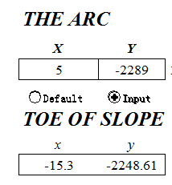
- coordinates
Step 4: Select steps and calculation method.
DBS-IWHR2015 can do either effective stress analysis or total stress analysis. Users can select method in METHOD . DBS-IWHR2015 adopts the grid search method to locate the critical slip surface. SEARCH 1 STEP and SEARCH 2 STEP can determine the size and density of the grid.
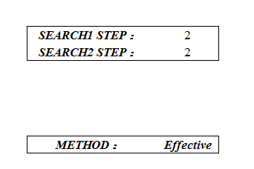
- Method and steps
Step 5: Calculate factor of safety of the sliding surface and search for the critical slip surface
Click button Calculate on menu, then DBS-IWHR will calculate factor of safety of the sliding surface and search for the critical slip surface. The result is shown as Fig.6. InFig.6, blue line is the slip surface of user and the red one is the critical slip surface.
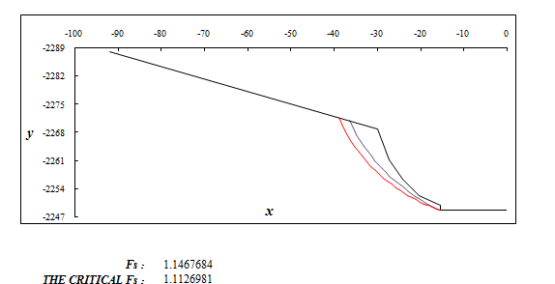
- result

Notes:
The real critical slip surface
Users should select the real critical slip surface through Worksheet Search and Search2.
Only when both the first round of search and the second round of search can find minimum of non-monotone curve, the searched critical slip surface is the real critical slip surface. This situation is shown as Fig.7.
search：
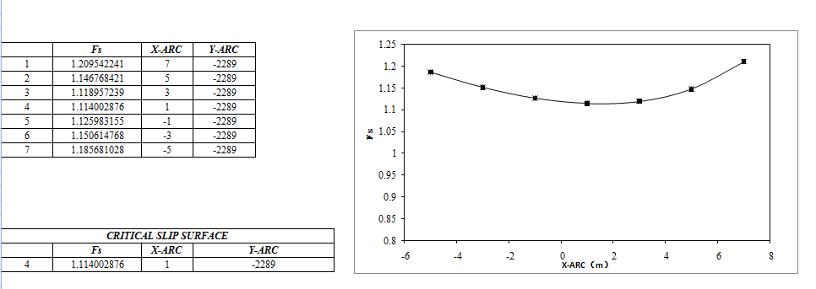
search2:
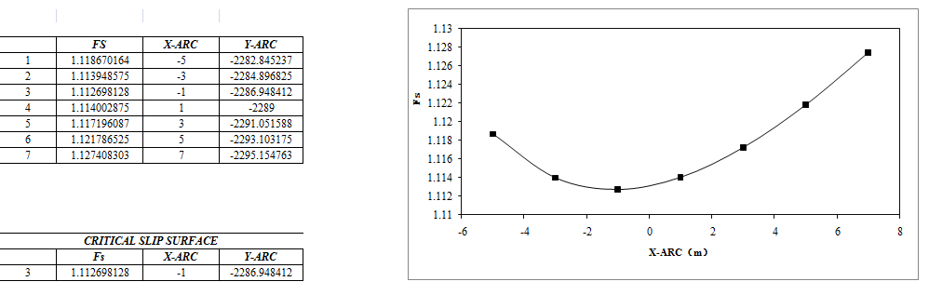
- The real critical slip surface
The fake critical slip surface
(1) There is a monotone curve in worksheet search, while it should be a non-monotone curve. This situation is shown as Fig.8.
Search
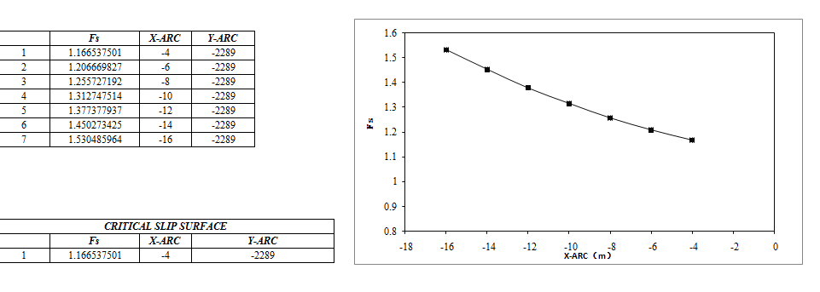
Search2
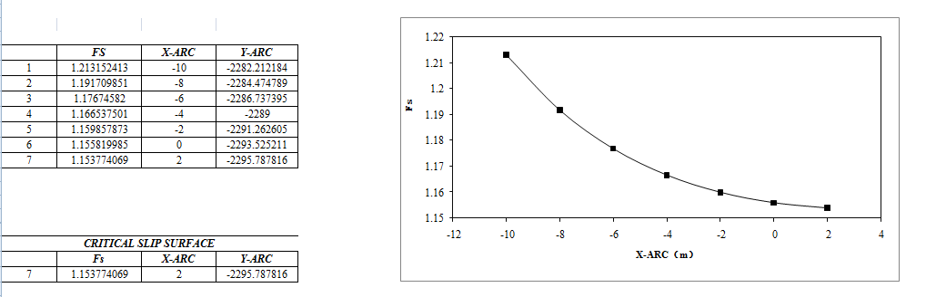
- The fake critical slip surface
When users meet this situation, they should change the center coordinates of circular arc in worksheet MAIN, then calculate and search until there is a non-monotone curve in both Worksheet search and Worksheet search2 as shown in Fig.9
Search：
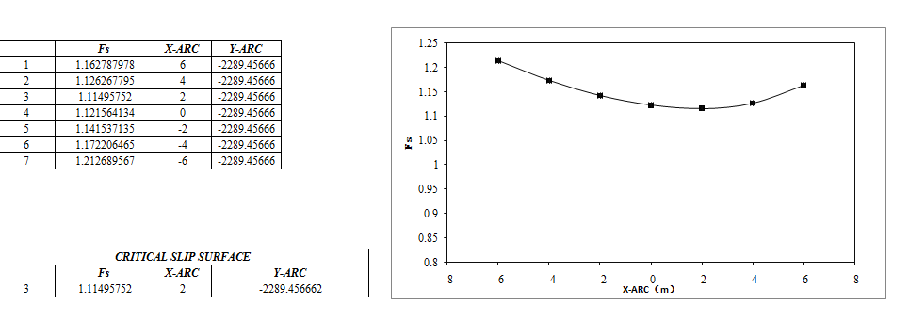
Search2：
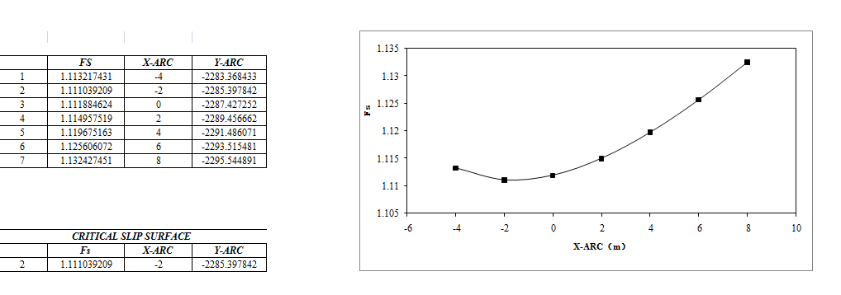

Example
1. Open Excel 1.xlsm. There is no center coordinates of circular arc shown as Fig.10.
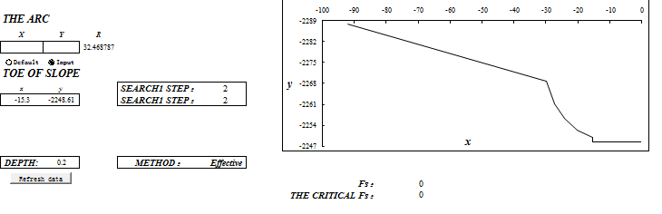
- Excel 1.xlsm
2. Input center coordinates of circular arc. In this example, x=5 while y=-2289.
Click button Calculate. The result is shown as Fig.11.

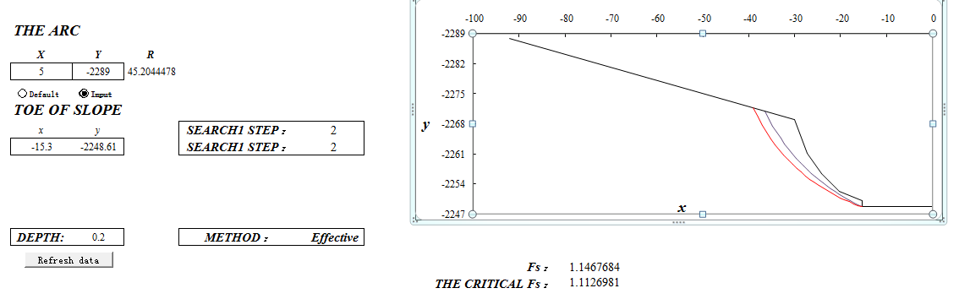
- Result
A critical slip surface can be found associated with Fs=1.113 that is greater than 1. This means that the original slope is safe.
3. With the erosion of the channel wall, the toe of the slope would be lower and move toward the bank. To simulate this erosion process, the toe of the slope is cut both vertically and horizontally by Δz, to create a new critical slope surface. By trial and error, it was found that a cut of Δz =1.4 m would result in a critical slip surface with Fs= 0.999, as shown in Fig.12.
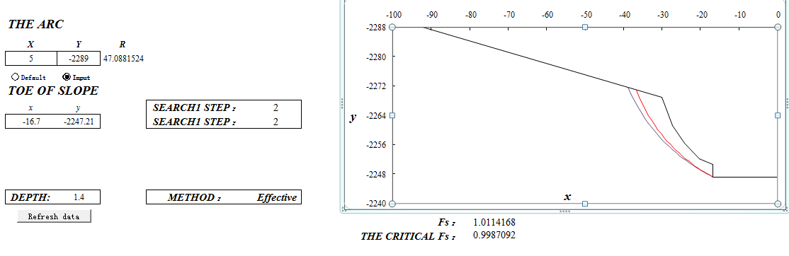
- Cut depth
4. Output the data and the critical slip surface searched will be a part of boundary lines next process. The new information of boundary lines is shown in Fig.13.
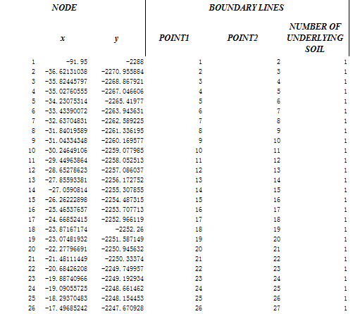
- New boundary lines
Repeat step1-3 until find next critical slip surface associated with Fs=1.

